Formal Mini-Case Rough Draft

After a thorough review of ASI’s current situation, we believe that by redesigning two new supply chains, moving manufacturing facilities, working with our 3PL, and designing new information flows ASI can increase sales, lower operating costs, and improve customer metrics.

**ASI’s Identity and Customers**

ASI is known as a good brand with innovative products. We do not own our supply chain and as such focus on innovative products as opposed to operating efficiencies.

Turning to our customers, the table below gives a quick snapshot of their supply chain needs and characteristics:

|  |  |  |  |  |  |  |
| --- | --- | --- | --- | --- | --- | --- |
| **Segment** | **Form** | **Time** | **Place** | **Volume** | **Volatility** | **Margin** |
| **Mass Merchants** | Low-end products | 2-3 days | Their DC | High | Low | Low |
| **Online & Specialty Outlets** | Entire product line | 5-7 days | Their DC | Medium | Medium | Medium |
| **Franchisees** | Customizable in-ground products | 7+ days | Their locations | Low | High | High |

**ASI’s Challenges**

Currently every customer segment is served the exact same way and each product is created equal. However, the table clearly shows different segments have very different demands of our supply chain. The simple truth is that no singular supply chain will be able to satisfy all segments. Digging deeper, ASI is contending with varying lead times, volumes, and volatilities. We believe that two new supply chains will be able to serve all segments while dealing with these different needs and variations.

**Designing the Supply Chains**

The summary of our supply chains can be found in the table below with justification following:

|  |  |  |  |  |  |  |
| --- | --- | --- | --- | --- | --- | --- |
| **Supply Chain** | **Products** | **Supply Chain Type** | **Production Location** | **Logistics** | **Customers** | **Priority** |
| **A** | Innovative e.g. in-ground & high-end training products | Responsive | Mexico | Trucking | Mass merchants; online & specialty outlets | High |
| **B** | Low-end e.g. home collars | Efficient | Mexico | Rail | Online & specialty outlets; franchisees | Low |

**The Case for Two Supply Chains**

We feel that when diving into the form and time needs as well as volume and volatility characteristics of our customers two separate patterns emerge. Our low-end products are requested in higher volumes, lower variation, and shorter replenishment cycle times while innovative products have lower volumes, more variation, and longer replenishment cycle times. Breaking the supply chain into three supply chains in pursuit of more specialization would present problems. A supply chain for each customer may give more attention to those relationships but the online & specialty outlet customers would be in a bind as their supply chain would simply be a miniature version of our current supply chain; it would need to produce all products subject to middle of the road volume and variation. Four or more supply chains would have similar problems so it appears two is the best choice.

**Our Solution**

**Responsive vs. Efficient**

**Sourcing/Procurement/Manufacturing**

Although these three functions are very different, ASI currently ties them together. Recent complaints in this area include long lead times and rising COGS, not to mention high pipeline inventory.

We believe that by moving all three functions to Mexico ASI can solve all of these problems. Long lead times could be reduced by as much as 4 weeks while cutting costs by $2,500 per 40ft. container according to J.P. Morgan[1]:

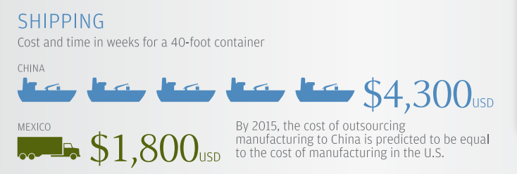

Further, after adjusting for productivity Mexico far out produces China[2]:

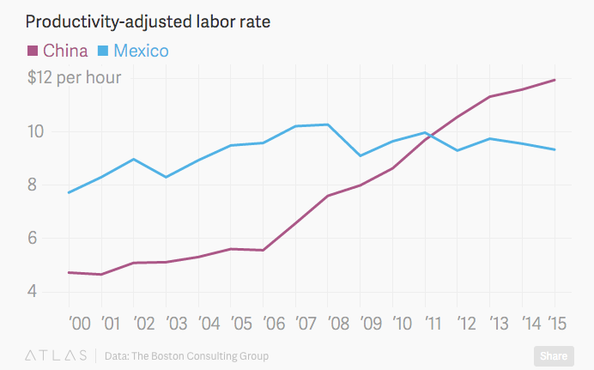

We expect this to reduce COGS, even if it turns out sourcing and procurement costs go up slightly. Thus this move to Mexico is a win-win and should be implemented in both supply chains going forward.

**Logistics**

Supply chain A

**Warehousing**

**Outbound Logistics**

**Service Level Targets**

**Other Considerations**

We realize that moving production facilities is no easy task. As an immediate remedy to our lead times or in the case moving is not feasible at this time, we recommend working with our Chinese manufacturers to move raw materials in-bound before we place orders with them.

ASI should consider licensing, selling off, or shutting down its low-end products.

Consider helping franchisees reduce inventory and capturing some of that value

Beware bullwhip effect from franchisees

1. https://www.chase.com/content/dam/chasecom/en/commercial-bank/documents/china-vs-mexico-infographic.pdf
2. http://qz.com/538056/the-country-china-outsources-to-when-chinese-labor-gets-too-expensive/